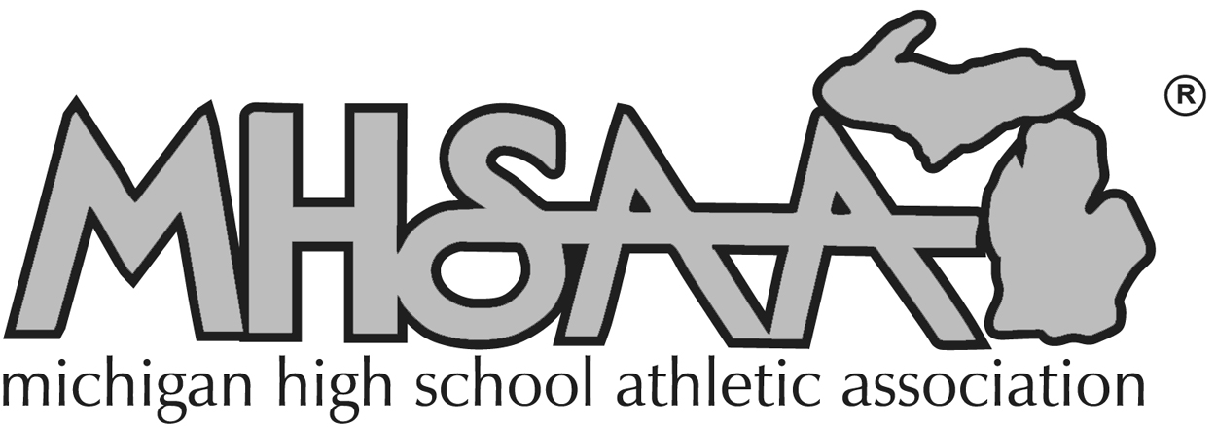
Awards Nomination

Return either by fax (517) 332-4071 or by mail to: MHSAA, 1661 Ramblewood Dr, East Lansing, MI 48823

(Check one or more)

❐ Charles E. Forsythe Award  Allen W. Bush Award

❐ Vern L. Norris Award  Women in Sports Leadership Award

❐ National High School Sports Hall of Fame
PLEASE TYPE ALL INFORMATION SUBMITTED TO MHSAA
HANDWRITTEN FORMS WILL NOT BE ACCEPTED

Date: _______________________

1. CANDIDATE:

Name: _______________________________________________________________________________

Home Address: ________________________________________________________________________

City: _________________________________________ State: _________________ Zip: ___________

Home Phone: (____) _____________________________ Business Phone: (____) __________________

OFFICIALS ONLY:

Association: ___________________________________________________________________________

Years Registered: ________________ Sports: _______________________________________________

2. EMPLOYMENT INFORMATION:

Present Position: _______________________________________________________________________

Years of Service: ___________________

Employer: ____________________________________________________________________________

Location: ____________________________________________________________________________

3. EDUCATIONAL BACKGROUND:

______________________________________________________________________________________

______________________________________________________________________________________

______________________________________________________________________________________

______________________________________________________________________________________

4. PROFESSIONAL ORGANIZATION:

______________________________________________________________________________________

______________________________________________________________________________________

______________________________________________________________________________________

______________________________________________________________________________________

______________________________________________________________________________________

5. HONORS and AWARDS

______________________________________________________________________________________

______________________________________________________________________________________

______________________________________________________________________________________

______________________________________________________________________________________

6. COMMUNITY SERVICE:

______________________________________________________________________________________

______________________________________________________________________________________

______________________________________________________________________________________

7. SIGNIFICANT ACHIEVEMENTS and CONTRIBUTIONS (including service to MHSAA):
______________________________________________________________________________________

______________________________________________________________________________________

______________________________________________________________________________________

______________________________________________________________________________________

______________________________________________________________________________________

NOMINATOR: _____________________________________________________________________________

Nominator Address: ___________________________________________________________________________________

City: _________________________________________________________ State: _____________ Zip: ____________

(Additional letters of recommendation may be attached to application form.)

Return either by fax (517) 332-4071 or by mail to: MHSAA, 1661 Ramblewood Dr, East Lansing, MI 48823

MHSAA AWARDS

Charles E. Forsythe Award

This award is named for the first MHSAA
executive director and has been presented annually
since 1978, to one or two individuals at the Boys
Basketball Tournament in March.

1. Qualifications:
A. Twenty or more years of service with a
Michigan school district
B. Presently active – or retired
C. Outstanding & distinctive service to Michigan
interscholastic athletic programs

2. Nominations & Selection Procedure:
A. Nominations will be accepted from:
Representative Council members, Michigan
professional education associations, leagues
& conferences, officials organizations, and
individual school administrators.
B. Application deadline is October 15 with final
selections made by the Representative
Council at its annual fall meeting.

Vern L. Norris Award

This award is presented annually at the MHSAA
Officials Banquet in April and is named for the
Association's third executive director.

1. Qualifications:
A. Twenty or more years of officiating registration
with the MHSAA.
B. Officiating experience at the high school level
C. Active in local officials' associations
D. Experience as a mentor for other officials and
involvement in official's education

2. Nominations and Selection Procedure:
A. Nominations will be accepted from Representative Council members, professional education associations, leagues and conferences, officials associations, and individual school administrators.
B. Application deadline is February 15 with the final election made by the Representative Council at its March meeting.
C. One person will be selected each year.

Allen W. Bush Award

Named for the second executive director of the MHSAA,
the awards are presented at appropriate occasions
selected by the recipients.

1. Qualifications:
A. Nominee may be an administrator, coach, official, trainer, doctor or member of the media with at least 15 years of experience in Michigan interscholastic athletics.
B. Frequent and significant contributions to the MHSAA

2. Nominations and Selection Procedure:
A. Nominations will be accepted from Representative Council members, professional education associations, leagues and conferences, officials associations, and individual school administrators.
B. Application deadline is April 1 with final selection made by the Representative Council at its May Meeting
C. Up to eight persons may be selected annually.

Women In Sports Leadership Award

This award is presented annually during the "Women in Sports Leadership Conference" sponsored by the MHSAA in January or February.

1. Qualifications
A. Nominee may be a coach, official, administrator or educator who has made major contributions in encouraging women for positions as athletic administrators, coaches and officials.
B. Participation with students, faculty and community concerning women's issues and development of directions for resolution.

2. Nominations and Selection Procedure:
A. Nominations will be accepted from Representative Council members, professional education associations, leagues & conferences, officials organizations, and individual school administrators.
B. Application deadline is October 15 with final selections made by the Representative Council at its annual fall meeting.

National High School Sports
Hall of Fame

General Criteria

Nominees must exemplify the highest standards of sportsmanship, ethical conduct and moral character.

The categories of athlete, coach, official and others are included on the nomination form for expediency in understanding the primary area in which an individual is to be considered for his or her achievements in interscholastic athletics. The grouping is for screening purposes only and to assist those making the nomination in understanding the type of information required. Once nominees are inducted, they are not categorized, but all are recognized as members of the National High School Sports Hall of Fame.

All candidates for the Hall of Fame must be at least 35 years of age prior to November 15 of the applicable year in order to be considered for induction. This includes candidates in all four categories.

To further explain, athletes would be former student participants who are being nominated for their achievements in interscholastic athletics. Coaches would be considered on the merits of their high school coaching achievements only and officials on the basis of their service as a high school official. The other category is for those individuals who have made contributions to interscholastic athletics in some capacity other than those previously mentioned, including such areas as administration, sports medicine and sports media.

ALL CANDIDATES WILL BE JUDGED ON THEIR SIGNIFICANT AND/OR LONG-TERM CONTRIBUTIONS TO INTERSCHOLASTIC ATHLETICS. WHILE MANY HAVE SERVED THEIR STATE AND LOCAL PROGRAMS OVER A LONG AND DISTINGUISHED CAREER, THEIR ACCOMPLISHMENTS MUST HAVE BEEN WORTHY OF NATIONAL RECOGNITION FOR THEM TO BE CONSIDERED. LONGEVITY, WITHOUT MEANINGFUL NATIONAL IMPACT, DOES NOT CONSTITUTE APPROPRIATE CREDENTIALS FOR HALL OF FAME CONSIDERATION.

Nominees for the Hall of Fame will either be 1) Approved and sent on to the Selection Committee, 2) Put
on "Hold" or 3) Placed in the "inactive" category. The "Holding for Future Consideration" category means a nominee may be considered again for induction and that additional information and supportive material would be helpful before future consideration. "Inactive" indicates that the nominee no longer will be considered for Hall of Fame induction until renominated. A one-year waiting period is required before renomination.

